**Sunkari Manohar**

**Assessment 3 – 30/12/2023**

**Visualizations in Databricks Notebook:**

* **Create a new visualization:**

Using example created the visualization:

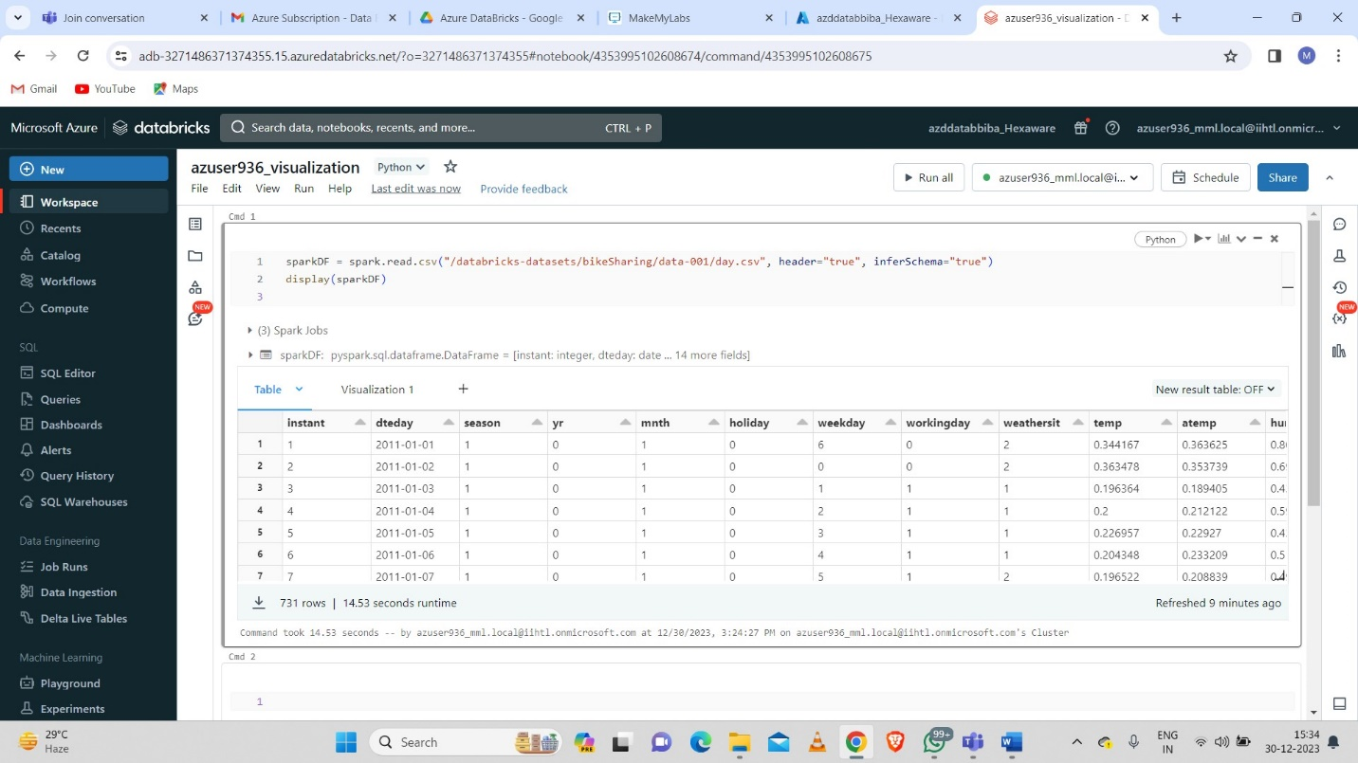

To create a visualization, click **+** above a result and select **Visualization**. The visualization editor appears.

* **Visualization:**

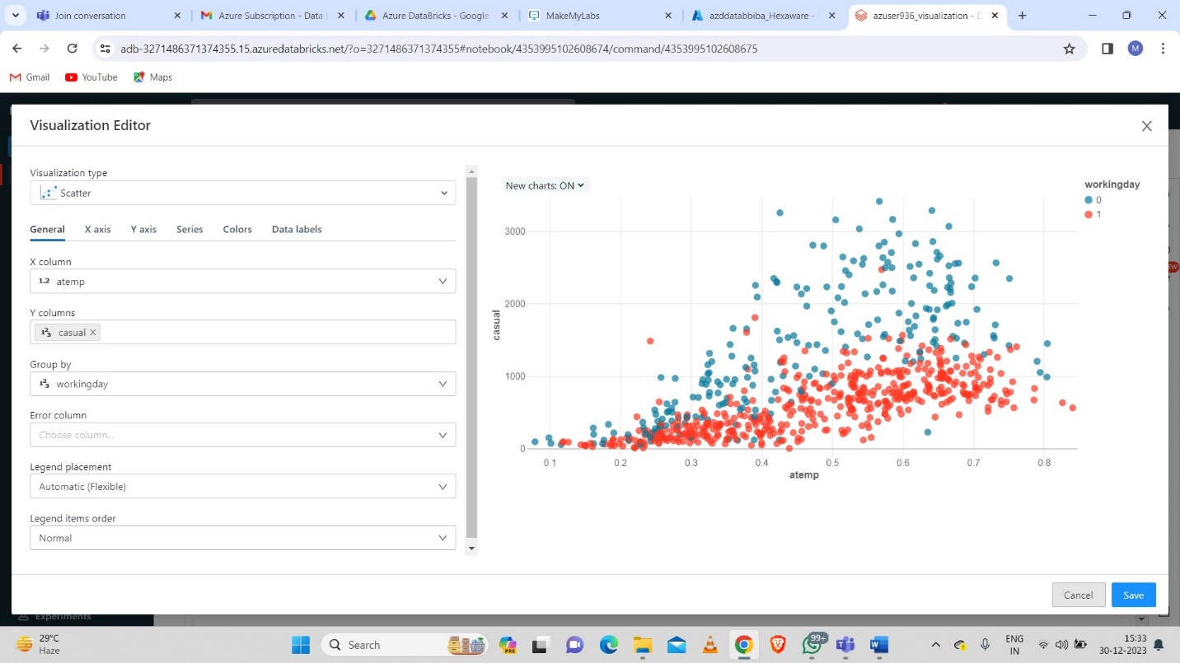

Then we need to click on save button to save the visualization.

* **Creating a new data profile:**

To create a data profile from a results cell, click **+** and select **Data Profile**.

* Databricks calculates and displays the summary statistics.

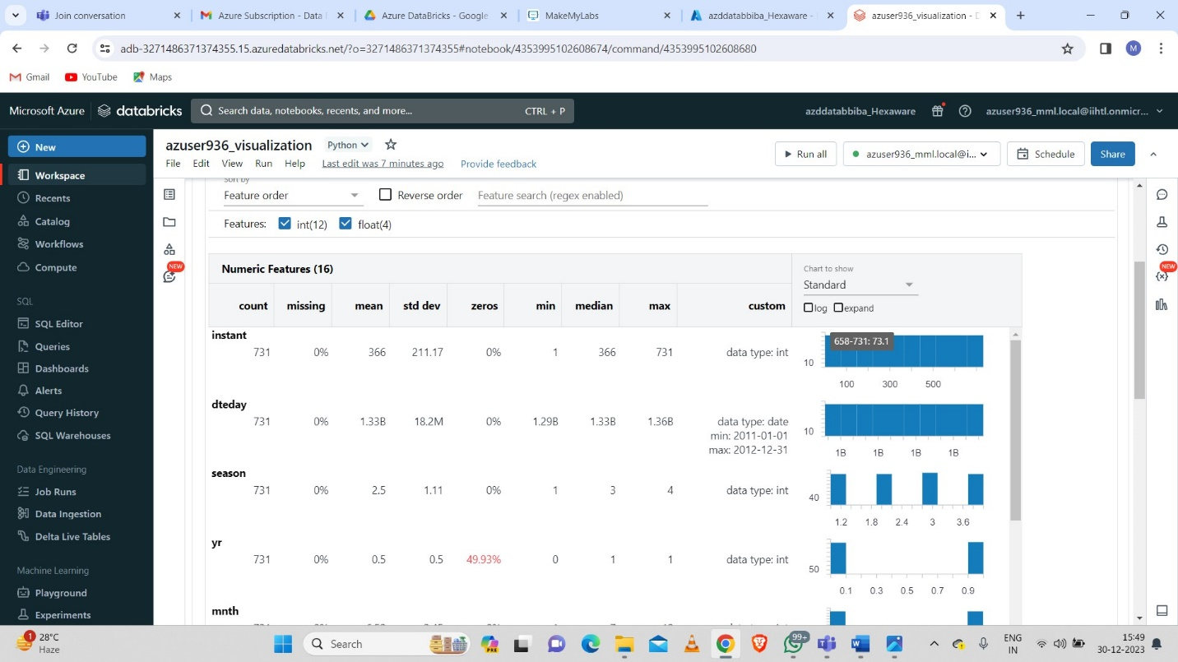

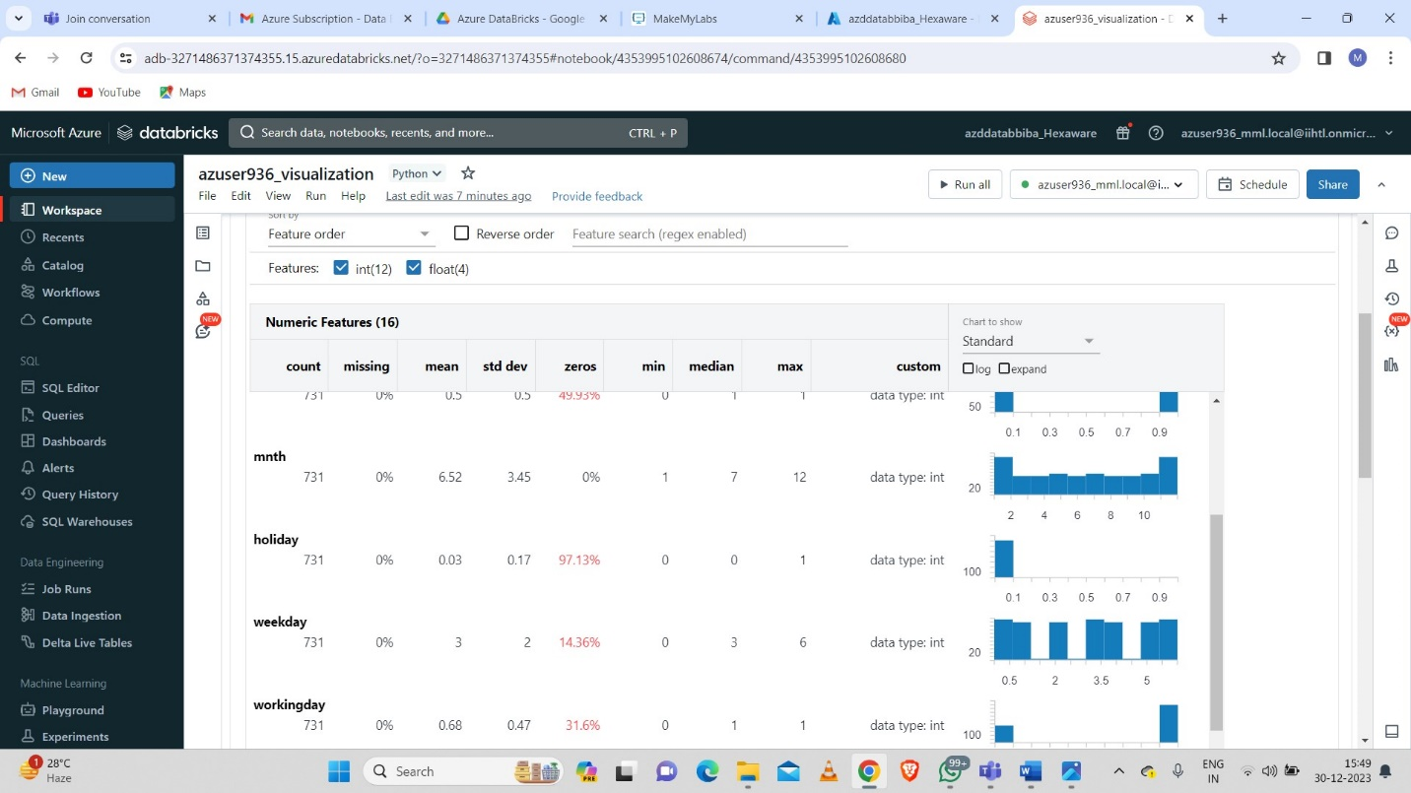

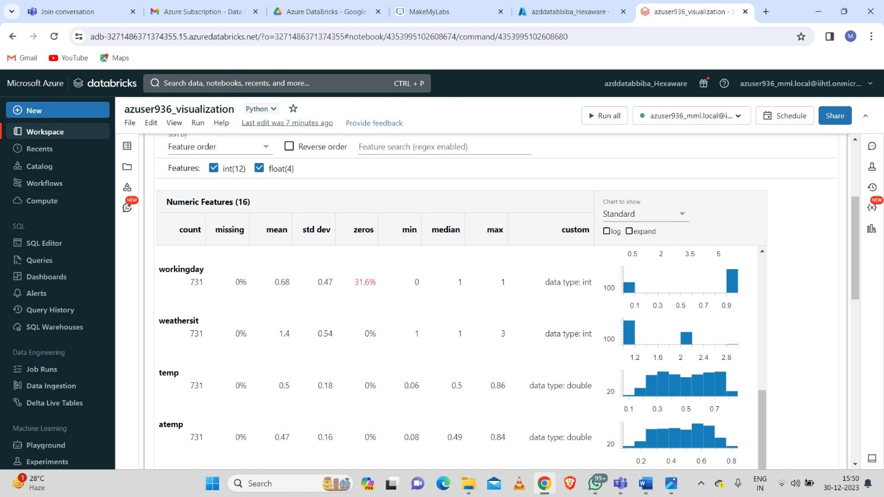

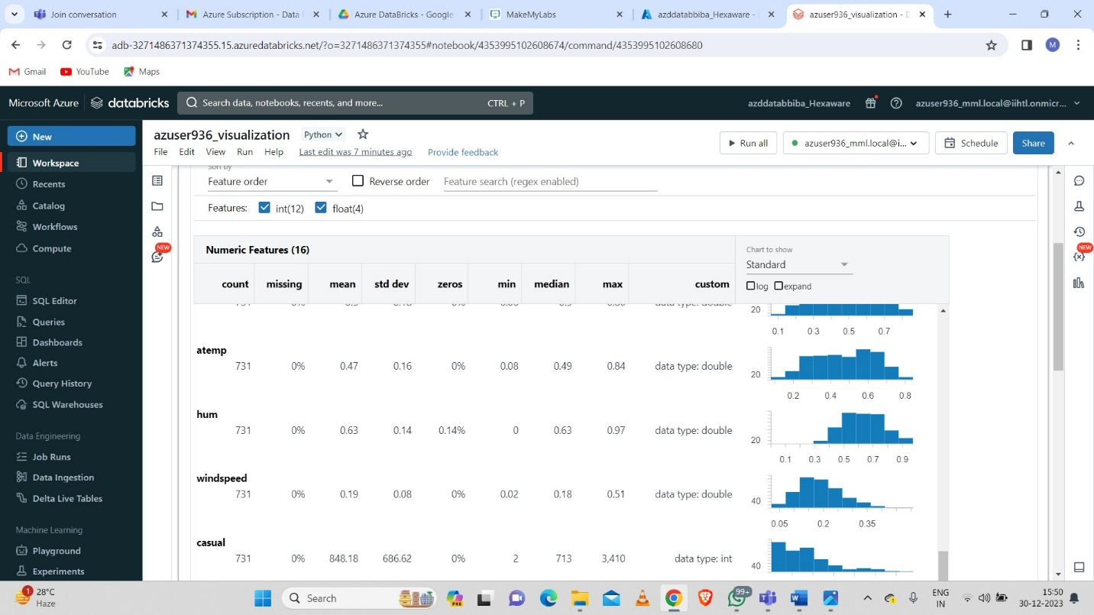

* **Now worked on visualizations and data profiles.**

**Renaming, duplicate, or remove a visualization or data profile:**

To rename, duplicate, or remove a visualization or data profile, click the downward pointing arrow at the right of the tab name.

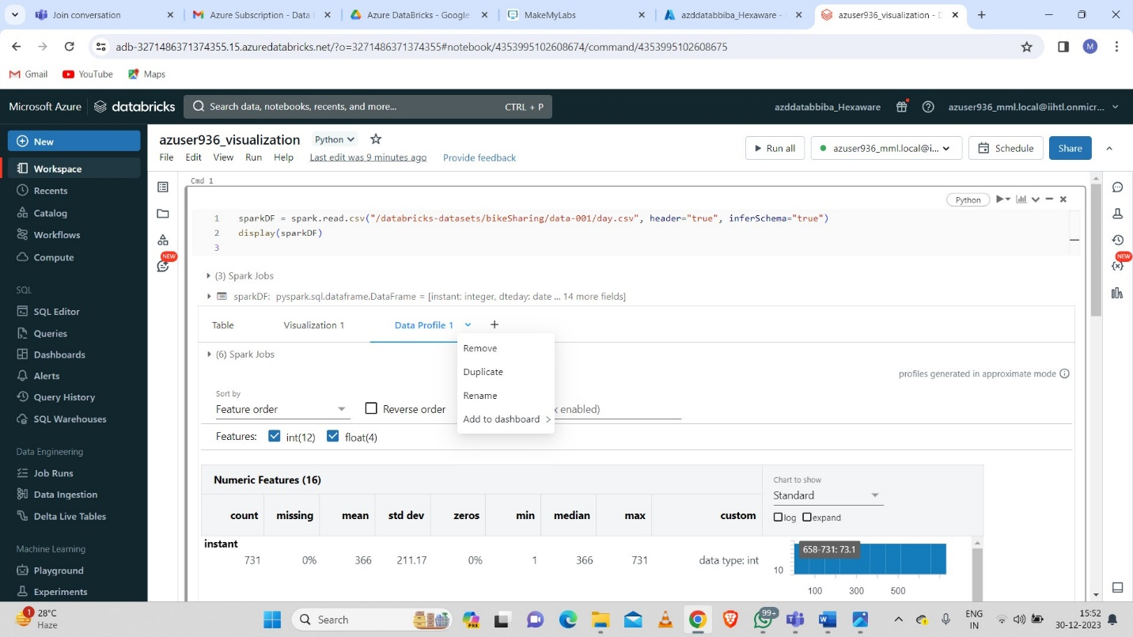

* **Edit a visualization:**

Click on Edit visualization tab to edit.

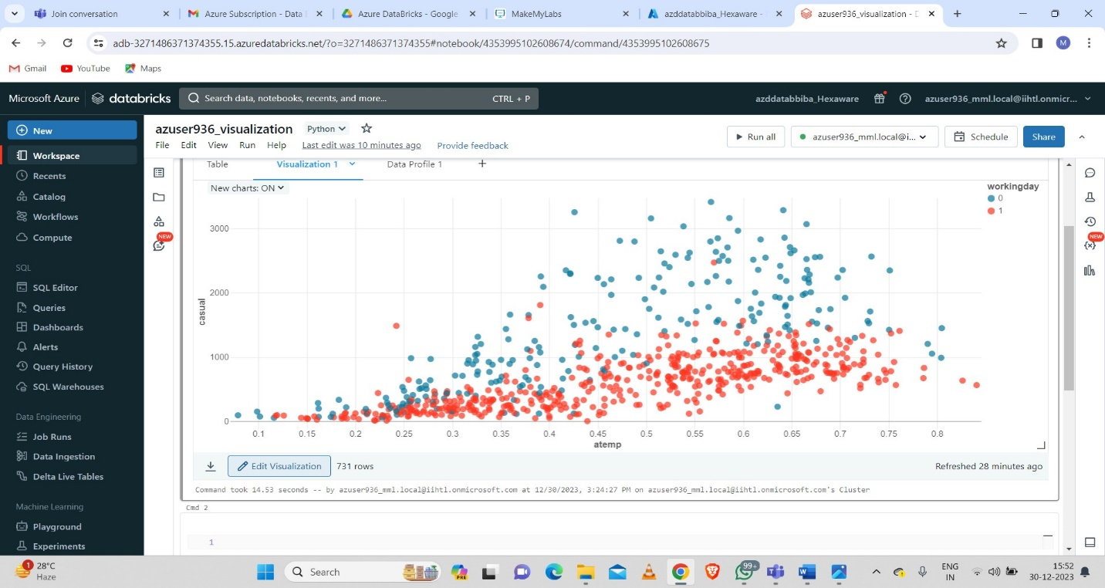

* **Editing colors:**

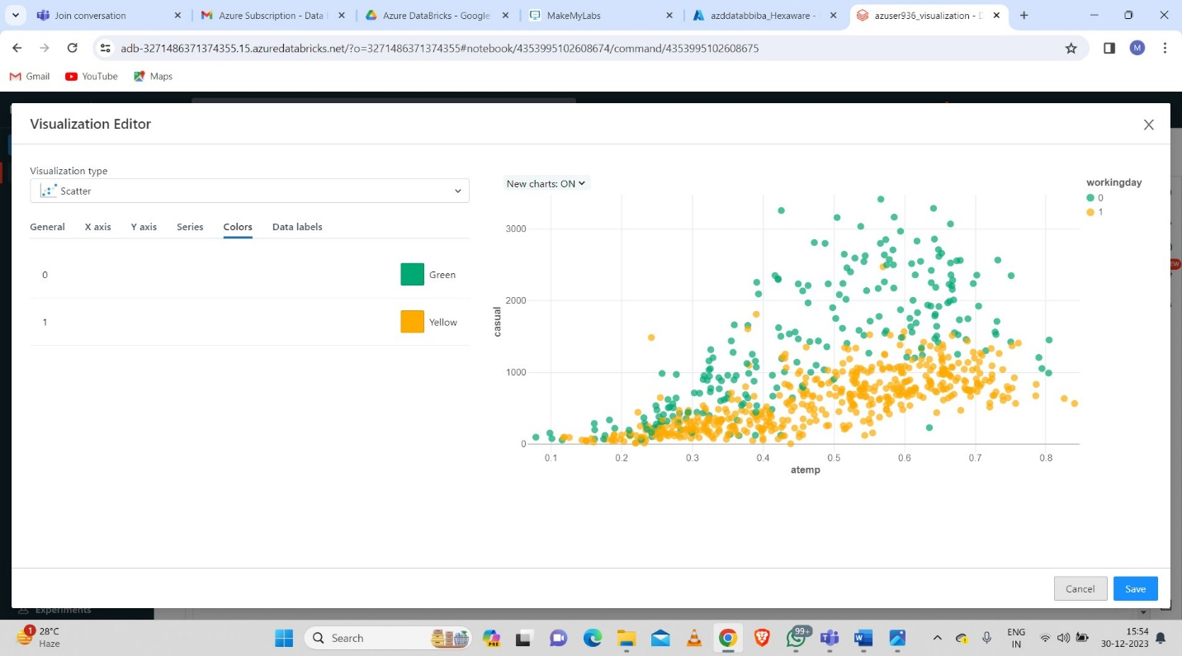

* **Download a visualization:**

To download a visualization in .png format, click the download icon in the notebook cell or in the visualization editor.

